Few Examples of current state:
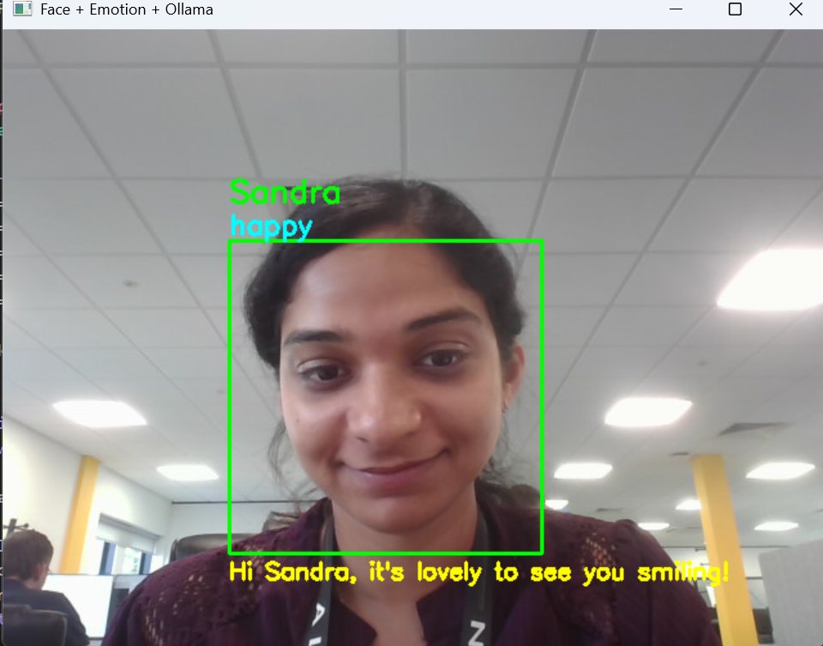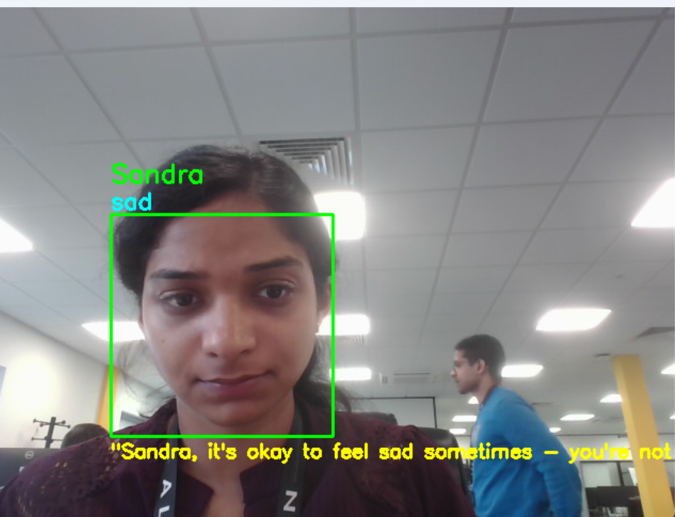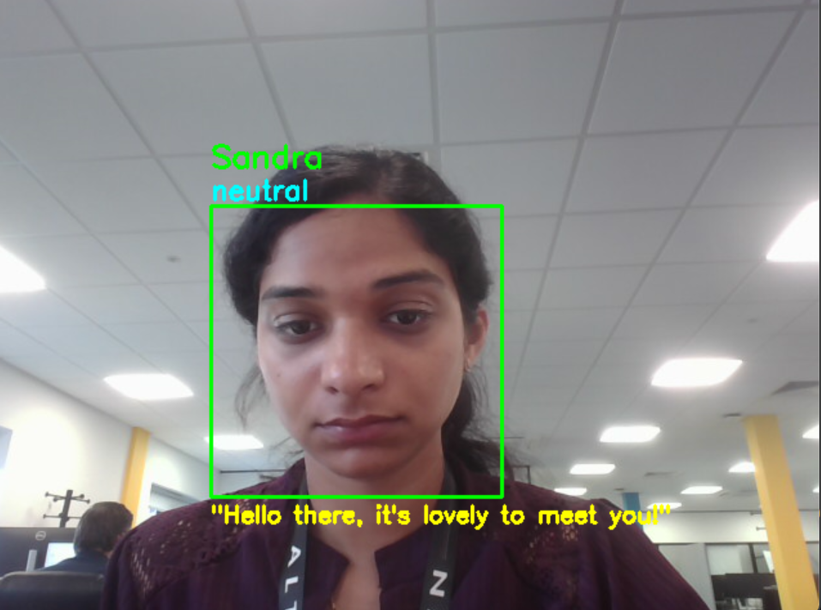

Main Libraries/Models Used:
- Cv2 (OpenCV)
  - Webcam access
  - Face detection (bounding box)
  - Show video feed
- Haar Cascade Classifier (may change)
  - Face detection
- DeepFace
  - Face Recognition
  - Emotion Detection
- Ollama Model (Llama 3.2)
  - Chat response for the emotion

Next major steps:
- FrontEnd
- Backend (FastAPI)
- Faster Recognition

